HOTEL MANAGEMENT SYSTEM

Submitted by

K. JANANI (192121041)
- KEVIN CHRISTOPHER (192121044)

In partial fulfillment for the completion of the

Project



Department of PROGRamming
SAVEETHA SCHOOL OF ENGINEERING
SAVEETHA INSTITUTE OF MEDICAL AND TECHNICAL SCIENCES,
CHENNAI – 602 105

SEP 2022

SUPERVISED BY

Dr. Vijay Bhaskar
BONAFIDE CERTIFICATE

This is to certify that the project report entitled “Hotel management system" submitted by " K.Janani (192121041), B. Kevin Christopher (192121044) ”to Saveetha School of Engineering, Saveetha Institute of Medical and Technical Sciences, Chennai, is a record of bonafide work carried out by him/her under my guidance. The project fulfills the requirements as per the regulations of this institution and in my appraisal meets the required standards for submission.

K. Vijay Bhaskar
Department of Programming

Internal examiner External Examiner
ACKNOWLEDGEMENT
I take immense pleasure in expressing my gratitude to our Honourable Chancellor, Dr. N. M. VEERAIYAN for being our constant source of inspiration.

I sincerely thank our Vice-Chancellor, Dr. L. JAWAHAR NESAN for providing the academic ambience to complete the project successfully.

With profound gratitude, respect and pride, I express my sincere thanks to our Director, Mrs. RAMYA DEEPAK, whose enthusiasm and dynamism being the driving force behind all our accomplishments.

I take this opportunity to extend our heartiest thanks to our beloved Principal, Dr. Ramesh for providing us excellent facilities and unstinting support which were the sustaining factors in carrying out the work successfully.

I owe a deep sense of gratitude to Dr. Vijaya Bhaskar, Department of Programming, for his keen interest on me at every stage of my project.

It is a genuine pleasure to express my deep sense of thanks and gratitude to my mentor Dr. Sungeetha Asst.Prof/Asso.Prof, Department of Nanotechnology. His/her dedication and keen interest had been solely and mainly responsible for completing my work.
Also, I am greatly indebted to my project guide Dr. Vijay Bhaskar Department of Biotechnology. His timely advice, meticulous scrutiny and scientific approach have helped me to a very great extent to accomplish this task.
Last, but not least, a very special thanks to my parents and friends for their moral support and care extended during the demanding times.
ABSTRACT

The Project HOTEL MANAGEMENT SYSTEM is a web based application that allows the hotel manager to handle all hotel activities online. Interactive GUI and the ability to manage various hotel bookings and rooms make this system very flexible and convenient. The hotel manager is a very busy person and does not have the time to sit and manage the entire activities manually on paper. This application gives him the power and flexibility to manage the entire system from a single online system.

Hotel Management project provides room booking, staff management and other necessary hotel management features. The system allows the manager to post available rooms in the system. Customers can view and book room online. Admin has the power of either approving or disapproving the customer's booking request.

Other hotel services can also be viewed by the customers and can book them too. The system is hence useful for both customers and managers to portably manage the hotel activities.

INTRODUCTION

Hotel Management System is a system that provides us to reserving rooms, checking whether the rooms are vacant are or not etc. by using online browsing. This system is very useful to all especially for business people.
For Business people they don’t have sufficient time for these then they can use these type of online Hotel Management Systems. By this project we will reduce the faults in bills of their expenditure and decrease time of delay to give the bills to the customers. We can also save the bills of the customer. By this project we can also include all the taxes on the bills according to their expenditures. It has a scope to reduce the errors in making the bills. Computerized bill can be printed within fraction of seconds. Online ordering of Booking is possible by using this software. This Project is based on php. If anyone wants to book the room for few days then they can specify the specific number by seeing the types of rooms we have. The bill of this online booking is based on the type of room they can select is displayed.
HOTEL MANAGEMENT SYSTEM is a hotel reservation site script where site users will be able to search room’s availability with an online booking reservations system. Site users can also browse hotels, view room inventory, check availability, and book reservations in real-time. Site users enter check in date and check out date then search for availability and rates. After choosing the right room in the wanted hotel – all booking and reservation process is done on the site and an SMS is sent to confirm the booking.
Administrator Panel
Account Manager
Administrator – Administrator can add / edit and manage administrator accounts.
Hotels Manager
Hotels – Administrator can manage hotels that will appear on the site with the hotel name, description, facilities, phone and fax
Room Types – Administrator can define the type of rooms in the hotels, room’s prices and upload an image for each room.
Hotel Rooms – For each Hotel the administrator can define the rooms available, room’s number, max occupants and remarks on the specific room.
Bookings – All booking and reservations maid on the site are displayed with all booking details: arrival date, departure date, hotel name, room type, number of passengers, price.
Available rooms – Administrator can also search for room availability from the administrators panel and does not have to go on the site Reports.
Booking Statistics – Administrator can view statistics of booking on bar charts that show the difference in bookings according to months.
Site Settings – Here the administrator can define if to use paypal on the site and if yes then what will be the pay-pal email address used, the administrator can also define the administrator email address where all reservation emails will be sent to.

LITERATURE SURVEY-1
- Hotel management and marketing on the internet: An analysis of sites and features

Author: Jamie Murphy, Edward J. Forrest,C.Edward Wotring, Robert A. Brymer
- Publication: The Cornell Hotel and Restaurant Administration Quarterly

- Many hotel managers and hotel-operating companies are attempting to use the internet and worldwide web as an effective management and marketing tool. An exploratory survey finds thousands of hotel-related sites. Available functions of a web page include: travel information, reservations and payment, special promotions, links to partners, direct consumer feedback, employment opportunities, audio and video ads, gift certificates, shareholder information, newsletters, frequently asked questions, and a list of and links to individual hotels. For any web site, there are five important considerations for its successful management: defining the mission, calculating the margins, addressing the mechanics, planning the marketing, and performing the maintenance.
- The ballyhoo surrounding the internet continues to intensify. To determine how the hotel industry is using this potentially revolutionary marketing and management tool, we took an exploratory look at the internet and at worldwide-web hotel sites. We looked at the type of hotel-related sites that exist on the web. We also surveyed the sites via e-mail, and the responses we gathered gave us valuable insights.

LITERATURE SURVEY-2
- What Makes for a Successful Hotel? Insights on Hotel Management Following 15 Years of Hotel Occupancy Analysis in England

Author: D. Jeffrey , R.R.D. Barden , P.J. Buckley & N.J. Hubbard
Publication: The Service Industries Journal
- Time series analyses of daily and monthly occupancy rates in different samples of hotels in England over a 15-year period reveal consistent temporal components of occupancy performance. These differentiate hotels in terms of overall occupancy levels, seasonality, length of season, trend and within-week variations. The components are related to the characteristics of hotels and their management using statistical methods and structured interview surveys, and the factors affecting occupancy performance of hotels are identified and calibrated.
- The internationalization of the business service sector is an area of rapid development. Foreign direct investment is the preferred manner of internationalization whereas international trade is less important. The process of internationalization can be explained by a combination of trade, investment and organizational theory. In applying these theories, the particular characteristics of services and the imperfections of markets for services must be taken into account. If this is done, the factors responsible for the international competitiveness of business service firms can be determined. The major determinants identified were examined empirically and then used as a basis for a survey based on questionnaires, followed up by interviews in the business service sector. The findings explain the low international competitiveness of German business service firms.

- LITERATURE SURVEY-3
- A review of the literature on culture in hotel management research: What is the future?

- Author: Rose X.Y. Chen,Catherine Cheung,Rob Law
- Publication: International Journal of Hospitality Management

- This paper aims to provide insights into the development of research on culture in the hotel industry by reviewing the existing literature. The papers were categorized into six major groups according to Pizam's (1993) hierarchy of cultures, and were further sorted by year of publication, source, subject area, region of focus, and the nature of the research. In contrast, few studies have investigated industry, occupational, and corporate cultures in association with hotel management studies, prompting concern for future research. In summary, this review paper offers a first and important attempt to understand the development of research on culture in the hotel management field and identifies future research opportunities.
- Some techniques were used more than once in a single paper, so there is a gain a mismatch between the total number of methods and articles. Quantitative studies (50%) formed the largest proportion, followed by conceptual studies (24%)
- As research on culture and hotels has progressed, quantitative research might be regarded as more appropriate when seeking to justify a theory or conceptual model.

LITERATURE SURVEY-4
- Competencies for Hotel Management: Industry Expectations of Education

Author: Tom Baum
Publication: International Journal of Contemporary Hospitality Management

- This article considers the very important issue of the expectations that employers in the hotel sector hold regarding graduate entrants. The article reports on a study in the UK which replicates and compares findings with a similar survey in the USA – 36 key competencies were rated by 118 general managers of hotels with more than 150 bedrooms. Conclusions are drawn with respect to the priority given to these competencies; their implications for educators; and the cultural variation implicit in comparing the US and UK findings.

- The purpose of this study is to investigate whether the current provision for graduate hospitality management education can fulfill the essential competency requirements for hospitality industry managers. A quantitative survey of hotel managers and graduate students was carried out, followed by in-depth interviews with educators and an analysis of relevant graduate program documents. The results show that leadership was perceived by hotel managers to be the most important competency, followed by industry knowledge and communication skills.

- LITERATURE SURVEY-5
- Does hotel management matter to overcoming the COVID-19 crisis?

Author: Alberto Hidalgo, David Martín-Barroso , Juan A. Nuñez-Serrano,Jaime Turrión,Francisco J. Velázquez
Publication: Tourism Management
- This paper analyses the influence that the initial actions and strategies pursued by hotel managers have on the recovery of occupancy after a crisis such as the COVID-19 pandemic. To do this, a specific survey is carried out on managers of Spanish hotels. The main findings show that labor actions, especially plans for temporary employment regulations, innovation and differentiation strategies, and reorientation to closer markets and obtaining information from official sources as a guarantee of their certainty, are the measures that have a greater impact on the possibilities of recovering hotel activity. In addition, government measures that contribute to the improvement of the financial situation of firms can also play a relevant role in hotel recovery.
- Taking appropriate strategies in response to the COVID-19 crisis has presented significant challenges to the hospitality industry. The qualitative findings suggest that 'rebuild strategies' dominated most hotels' response to the COVID-19 crisis while the quantitative findings confirm the direct impact of affective evaluation and cognitive effort on customer satisfaction. The results further reveal that hotels' crisis response strategies moderate the effects of affective evaluation and cognitive effort on customer satisfaction.

- TABULAR REPRESENTATION OF THE SURVEY
1. Overall, how friendly were the hotel staff members? | 2. Overall, how polite were the hotel staff members? | 3. Overall, how professional were the hotel staff members? | 4. How clean was your room upon arrival? | 5. How comfortable were your bed linens? | 6. Overall, how quickly did the hotel staff respond to your requests? | 7. How convenient were the hours of the food service options at our hotel? | 8. How delicious was the hotel breakfast service? | 9. How likely are you to stay at our hotel again? | 10. How likely are you to discourage others from staying at our hotel? | 11. How likely are you to stay at our hotel again?
Slightly friendly | Moderately polite | Extremely professional | Extremely clean | Extremely comfortable | Quite quickly | Moderately convenient | Very delicious | Slightly likely | Not at all likely | 8
Extremely friendly | Extremely polite | Extremely professional | Extremely clean | Moderately comfortable | Slightly quickly | Moderately convenient | Not at all delicious | Slightly likely | Quite likely | 9
Extremely friendly | Slightly polite | Quite professional | Slightly clean | Extremely comfortable | Quite quickly | Slightly convenient | Very delicious | Quite likely | Not at all likely | 8
Slightly friendly | Extremely polite | Quite professional | Extremely clean | Moderately comfortable | Extremely quickly | Quite convenient | slightly delicious | Slightly likely | Slightly likely | 7
Quite friendly | Extremely polite | Quite professional | Slightly clean | Extremely comfortable | Quite quickly | Quite convenient | Very delicious | Quite likely | Quite likely | 7
Extremely friendly | Extremely polite | Extremely professional | Extremely clean | Extremely comfortable | Extremely quickly | Slightly convenient | Very delicious | Quite likely | Slightly likely | 10
Extremely friendly | Extremely polite | Extremely professional | Extremely clean | Extremely comfortable | Extremely quickly | Moderately convenient | Very delicious | Quite likely | Not at all likely | 10
Quite friendly | Extremely polite | Quite professional | Extremely clean | Moderately comfortable | Slightly quickly | Moderately convenient | Very delicious | Quite likely | Moderately likely | 9
Extremely friendly | Extremely polite | Extremely professional | Extremely clean | Extremely comfortable | Extremely quickly | Slightly convenient | Very delicious | Quite likely | Not at all likely | 7
Extremely friendly | Extremely polite | Quite professional | Extremely clean | Slightly comfortable | Extremely quickly | Slightly convenient | slightly delicious | Slightly likely | Slightly likely | 8
Extremely friendly | Moderately polite | Moderately professional | Extremely clean | Moderately comfortable | Quite quickly | Moderately convenient | Very delicious | Quite likely | Not at all likely | 8
Extremely friendly | Slightly polite | Quite professional | Extremely clean | Extremely comfortable | Quite quickly | Moderately convenient | Very delicious | Quite likely | Slightly likely | 10
Moderately friendly | Extremely polite | Moderately professional | Extremely clean | Extremely comfortable | Extremely quickly | Moderately convenient | Very delicious | Quite likely | Moderately likely | 8
Extremely friendly | Extremely polite | Extremely professional | Extremely clean | Extremely comfortable | Extremely quickly | Quite convenient | Very delicious | Quite likely | Not at all likely | 10
Extremely friendly | Extremely polite | Extremely professional | Extremely clean | Extremely comfortable | Extremely quickly | Slightly convenient | slightly delicious | Quite likely | Slightly likely | 10
Quite friendly | Moderately polite | Quite professional | Quite clean | Slightly comfortable | Quite quickly | Quite convenient | slightly delicious | Slightly likely | Moderately likely | 9
Extremely friendly | Extremely polite | Quite professional | Extremely clean | Slightly comfortable | Quite quickly | Quite convenient | Very delicious | Quite likely | Slightly likely | 8
Extremely friendly | Quite polite | Extremely professional | Extremely clean | Moderately comfortable | Quite quickly | Quite convenient | slightly delicious | Quite likely | Slightly likely | 4
Extremely friendly | Extremely polite | Extremely professional | Extremely clean | Extremely comfortable | Extremely quickly | Slightly convenient | Very delicious | Quite likely | Slightly likely | 10
Quite friendly | Slightly polite | Slightly professional | Slightly clean | Extremely comfortable | Quite quickly | Moderately convenient | Very delicious | Slightly likely | Moderately likely | 8

HOTEL STAFF BEHAVIOR

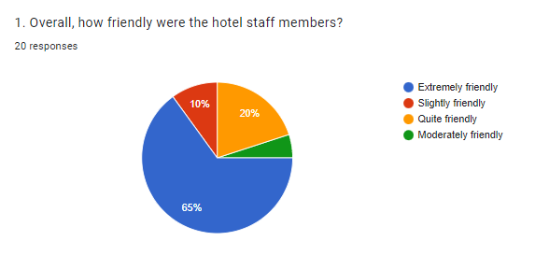

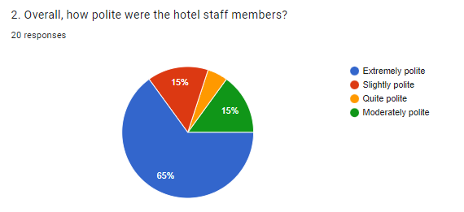
HOTEL STAFF BEHAVIOR

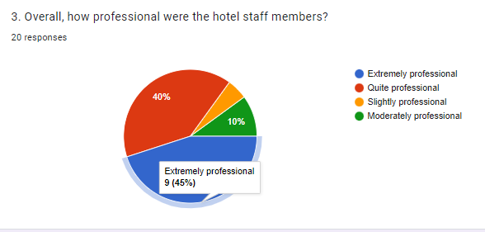

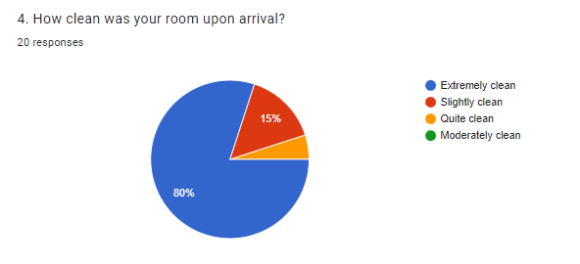

ROOM AND FOOD SERVICE

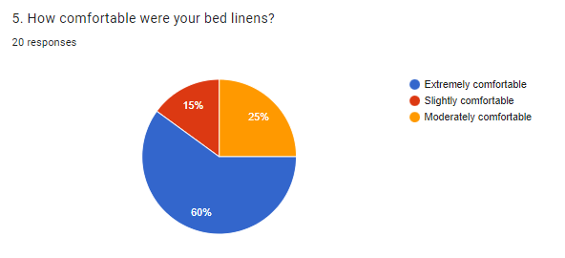

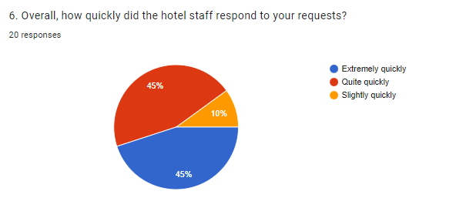

ROOM AND FOOD SERVICE

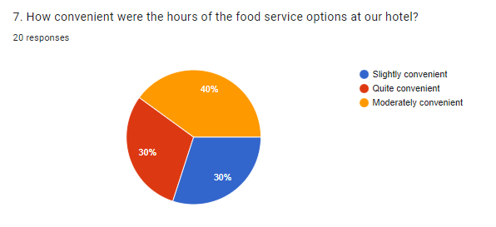

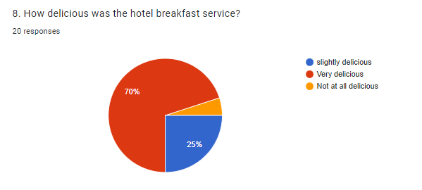

OVERALL REVIEW

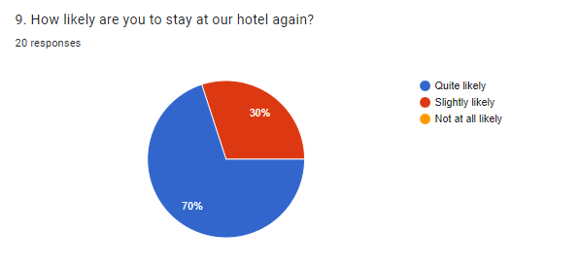

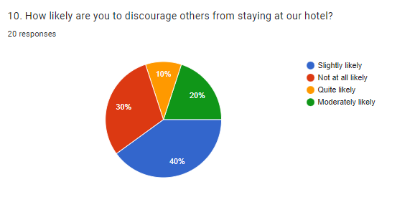

OVERALL REVIEW

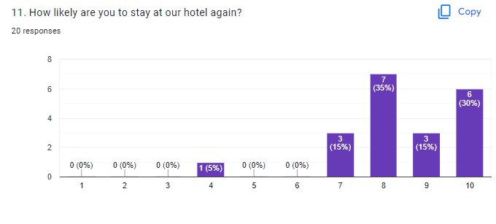

OBSERVATION AND RESULT

- The purpose of hotel booking system is to automate the existing manual system by the help of computerized equipment’s and full-fledged computer software, fulfilling their requirement, so that their valuable or information can be stored for a longer period with easy accessing and manipulating of the same .The above conducted survey shows the management that is
- carried out by the hotel :

- It shows that the staff were extremely polite and friendly to the customers.
- It shows that the system was quiet well managed and sharp around the clock.
- It shows that the rooms and the corridors were pretty clean and fresh for the customers.
- It seems that they were also pleased with food options and the taste of the food.
- It shows that the room service was good and around time.
- It is found that the customers are more likely to return to the same place and recommend it to others.

CONCLUSION

The conclusion of this project is A Hotel management system is a computerized management system. This system keeps the records of hardware assets besides software of this organization. The proposed system will keep a track of Workers, Resident's, Accounts and generation of report regarding the present status. This project has GUI based software that will help in storing, updating and retrieving the information through various user-friendly menu-driven modules.

The project “Hotel Management System” is aimed to develop to maintain the day-to-day state of admission/Vacation of Residents, List of Workers, payment details etc. Main objective of this project is to provide solution for hotel to manage most there work using computerized process. This software application will help admin to handle customer’s information, room allocation details, payment details, billing information, etc. The existing system is a manually maintained system. All the Hotel records are to be maintained for the details of each customers, Fee details, Room Allocation, Attendance etc. provides easy and quick access over the data.

We strive to build solutions to your specific needs to get the job done right the first time. We pay special attention to the ease of use and utilize the latest in technology. This system is developed for the exclusively for the people. It provides facilities to the user with user friendly modules with sub modules. This system is developed totally GUI based and with smart links.

REFERENCE

- https://www.mifratech.com/public/blog-page/Hotel+Management+System
- https://studylib.net/doc/25667912/hotel-management-system-project-presentation
- https://www.studymode.com/subjects/literature-review-for-a-hotel-management-system-page1.html
- https://scholar.google.com/scholar?hl=en&as_sdt=0%2C5&q=hotel+management+&btnG=#d=gs_qabs&t=1664250084268&u=%23p%3D9f_dBGxATo8J
- https://journals.sagepub.com/doi/10.1177/001088049603700322
- https://www.sciencedirect.com/science/article/abs/pii/0010880496868170
- https://m.x-mol.com/paper/1541525005930569728?recommendPaper=1420102150787260416
- https://docs.google.com/spreadsheets/d/1Z7K7nyC6VfcOAih6bu9PDL3dvu7U0DFWbKtnmKcZ1jc/edit?resourcekey#gid=253187513
- https://docs.google.com/forms/d/1KtJyb240YskX6EqaAsbqaQA4HApdVvA5K3KBPXWJ8uY/edit#responses

